FACULTY ADOPTION INSTRUCTIONS
- Go to madisoncollegebookstore.com
- Click on Faculty
- Sign in using your Madison College user name and password (case sensitive)
- 1st time you will get a faculty registration page fill out all of the starred fields (if not your first time skip to step 7)
a) You confirm you email by re-typing it
b) For the password field type in password1 (this is only for the form-you will never use again)
c) Phone number field must be 10 digits
d) Choose your department from the drop down box
5. Click Go to Faculty Page (faculty page is the page you will get first- now that you registered)
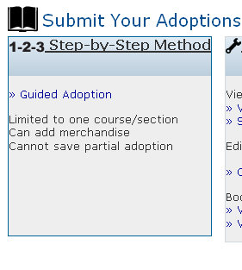
6. Click on Guided adoptions under 1-2-3 Step-by-Step Method
7. Step 1-Create your course
- Select term
- Department
Select add department
Choose department from drop down box
(Scroll down for new department subject name)
You must add department based on the new academic structure
Your new department name can be found in your faculty center
under subject
ie: instead of 001ACCT you would use ACCTG
ie: instead of 809PSYC you would use one of the following:
ECON; PSYCH; POLISCI; SOC; ANTHRO; PHILOS or SOCSCI
Click add
Click continue (repeat if adopting for other departments)
- Filter by instructor-optional (will bring up the courses you are teaching)
- Choose your course and section
- Instructor name field is filled in automatically (you can change if needed due to re-assignment)
- If your course does not require materials check the box
- Continue
8. Step 2-Adopt your books
- You are given 5 ways to adopt books:
Your book list (once you adopt your books are saved here)
Browse books (find books by category)
***Book search (key in ISBN; author or title) (recommended option)
History (search previous adoptions by department and term)
Add a book (if you have a duplication/book your create yourself)
9. Step 3-Select the usage of the books (required; optional; recommended; see instructor)
10. Step 4-Review and Submit
11. You have finished!!! You will receive an email confirmation of your order
12. Now you can go back and submit books for another class (if books are the same but for a different class #- then choose
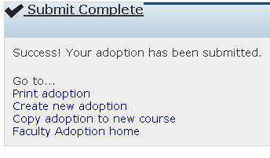
copy adoption to new course- in the submit complete box)
- You are taken back to course information page
- Change section #
- Review and submit
- Repeat as necessary

